**Assignment – 2**

Problem Statement:

Description:

1. Create a table called course with the following fields:

CourseId Int (6);

Title varchar (20);

Description varchar (20);

1. Create a table called student with the following fields:

StudentId varchar (5);

FirstName varchar (20);

LastName varchar (20);

1. Perform one-to-one relationship for id column in the above table.

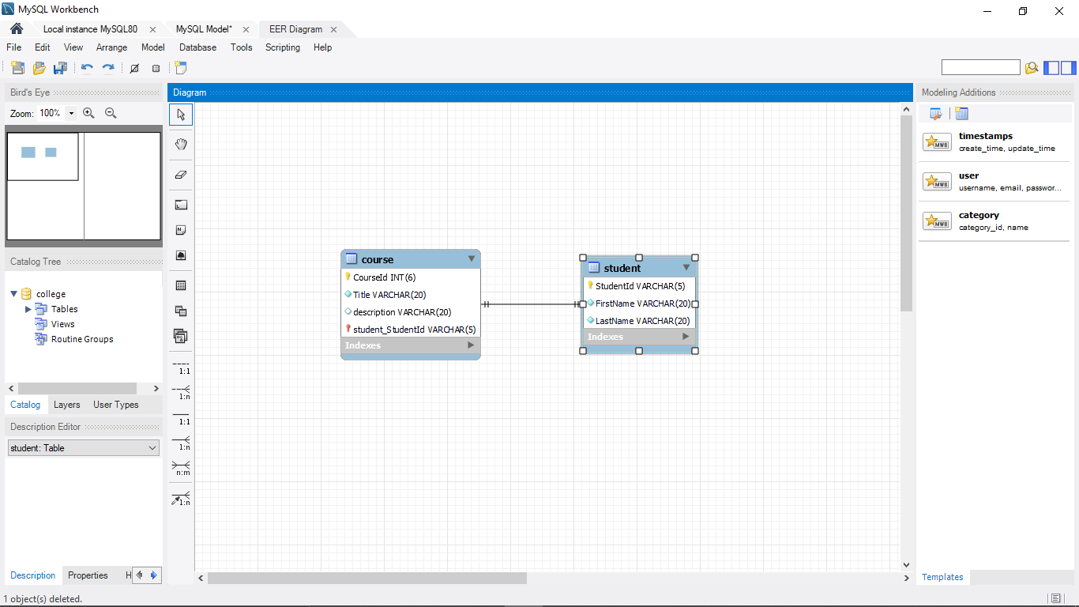

1. Perform one-to-many relationship for any columns in the above table.

